BluetoothTM Optical Slimline Mouse
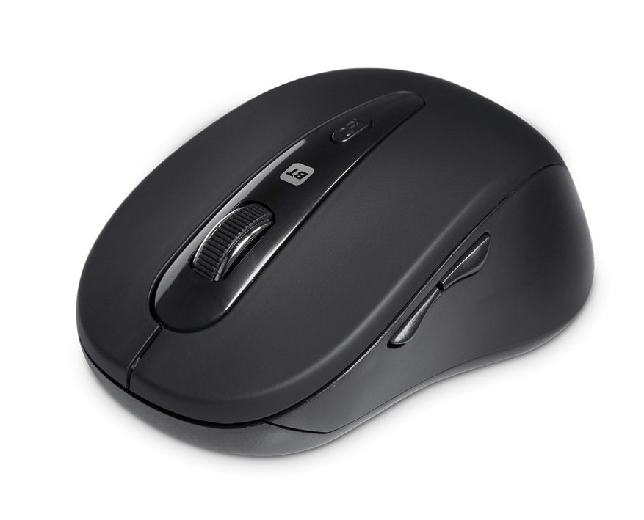

Descrption:

Enjoy complete wireless freedom using BluetoothTM connectivity to your notebook, MacBookTM PC or project computer. With up to 6 buttons on board including the scroll-wheel means you can take full control of your applications, games or multimedia experience.

Freedom from wires courtesy of BluetoothTM technology
No more messy USB cables. Complete wireless technology up to
10-metres (approx) from your PC, Notebook, MacBookTM etc

HD optical tracking
Selectable optical tracking on most surfaces with DPI select rates of
800/1200/1600dpi resolutions to suit your screen or app size

Stylish, modern and comfortable control
Total control using integral 3-button design and our accurate scroll-wheel and a low-profile design for an easy travel companion

Compatible with all your BluetoothTM computers
Ideal for WindowsTM, MacTM and MacBookTM together with almost all
other computers and project computers

SPECIFICATIONS
Wireless Connectivity : BluetoothTM V3 or equiv.
BluetoothTM Range : Up to 10-metres (approx.)
Buttons: 6-Button inc Wheel, DPI selection
Surface Tracking : HD Optical 800/1200/1600 DPI



